KPI Queries
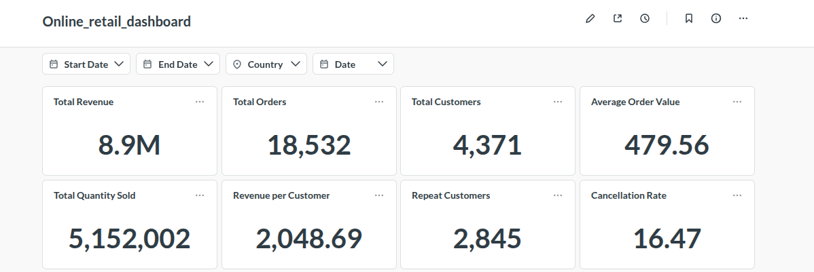

1. Total Revenue
SELECT
SUM(Quantity * UnitPrice) AS total_revenue
FROM online_retail1
WHERE InvoiceNo NOT LIKE 'C%'
AND Quantity > 0
AND UnitPrice > 0
[[AND {{date_filter}}]]
[[AND Country = {{country}}]];
Explanation: Calculates total revenue from all valid sales in the dataset, optionally filtered by date and country.

2. Total Orders
SELECT
COUNT(DISTINCT InvoiceNo) AS total_orders
FROM online_retail1
WHERE InvoiceNo NOT LIKE 'C%'
[[AND {{date_filter}}]]
[[AND Country = {{country}}]];
Explanation: Counts all unique orders to measure sales volume, considering optional date and country filters.

3. Total Customers
SELECT
COUNT(DISTINCT CustomerID) AS total_customers
FROM online_retail1
WHERE CustomerID IS NOT NULL
[[AND {{date_filter}}]]
[[AND Country = {{country}}]];
Explanation: Determines the total number of customers making purchases, which helps understand customer base size.

4. Average Order Value (AOV)
SELECT
SUM(Quantity * UnitPrice) / COUNT(DISTINCT InvoiceNo) AS avg_order_value
FROM online_retail1
WHERE InvoiceNo NOT LIKE 'C%'
AND Quantity > 0
AND UnitPrice > 0
[[AND {{date_filter}}]]
[[AND Country = {{country}}]];
Explanation: Calculates the average revenue per order, a key metric to understand customer spending behavior.

5. Total Quantity Sold
SELECT
SUM(Quantity) AS total_items_sold
FROM online_retail1
WHERE InvoiceNo NOT LIKE 'C%'
AND Quantity > 0
[[AND {{date_filter}}]]
[[AND Country = {{country}}]];
Explanation: Computes total items sold across all orders, useful for inventory and stock planning.

6. Revenue per Customer
SELECT
SUM(Quantity * UnitPrice) / COUNT(DISTINCT CustomerID) AS revenue_per_customer
FROM online_retail1
WHERE InvoiceNo NOT LIKE 'C%'
AND CustomerID IS NOT NULL
[[AND {{date_filter}}]]
[[AND Country = {{country}}]];
Explanation: Measures average revenue generated per customer, indicating value from each customer.

7. Repeat Customers
SELECT
COUNT(*) AS repeat_customers
FROM (
SELECT CustomerID
FROM online_retail1
WHERE InvoiceNo NOT LIKE 'C%'
AND CustomerID IS NOT NULL
[[AND {{date_filter}}]]
[[AND Country = {{country}}]]
GROUP BY CustomerID
HAVING COUNT(DISTINCT InvoiceNo) > 1
) t;
Explanation: Counts customers with more than one order, useful for understanding loyalty and retention.

8. Cancellation Rate
SELECT
COUNT(DISTINCT CASE WHEN InvoiceNo LIKE 'C%' THEN InvoiceNo END) * 100.0 /
COUNT(DISTINCT InvoiceNo) AS cancellation_rate
FROM online_retail1
[[WHERE {{date_filter}}]]
[[AND Country = {{country}}]];
Explanation: Measures the percentage of orders that were cancelled, important for operational insights.

Trend Analysis Queries

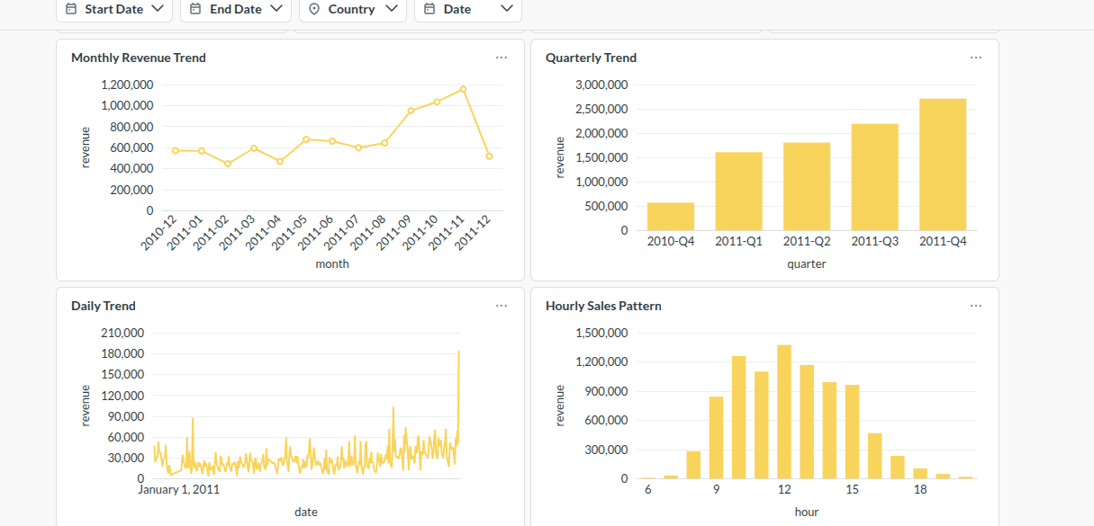

1. Monthly Revenue Trend
SELECT
DATE_FORMAT(InvoiceDate, '%Y-%m') AS month,
SUM(Quantity * UnitPrice) AS revenue
FROM online_retail1
WHERE InvoiceNo NOT LIKE 'C%'
AND Quantity > 0
AND UnitPrice > 0
[[AND {{date_filter}}]]
[[AND Country = {{country}}]]
GROUP BY month
ORDER BY month;
Explanation: Shows revenue trend by month, helping identify peak and off-peak periods.

2. Daily Revenue Trend
SELECT
DATE(InvoiceDate) AS date,
SUM(Quantity * UnitPrice) AS revenue
FROM online_retail1
WHERE InvoiceNo NOT LIKE 'C%'
AND Quantity > 0
AND UnitPrice > 0
[[AND {{date_filter}}]]
[[AND Country = {{country}}]]
GROUP BY date
ORDER BY date;
Explanation: Displays daily sales trends, useful for analyzing short-term fluctuations.

3. Hourly Sales Pattern
SELECT
HOUR(InvoiceDate) AS hour,
SUM(Quantity * UnitPrice) AS revenue
FROM online_retail1
WHERE InvoiceNo NOT LIKE 'C%'
AND Quantity > 0
AND UnitPrice > 0
[[AND {{date_filter}}]]
[[AND Country = {{country}}]]
GROUP BY hour
ORDER BY hour;
Explanation: Reveals sales distribution by hour, helping understand customer buying behavior during the day.

4. Quarterly Revenue Trend
SELECT
CONCAT(YEAR(InvoiceDate), '-Q', QUARTER(InvoiceDate)) AS quarter,
SUM(Quantity * UnitPrice) AS revenue
FROM online_retail1
WHERE InvoiceNo NOT LIKE 'C%'
AND Quantity > 0
AND UnitPrice > 0
[[AND {{date_filter}}]]
[[AND Country = {{country}}]]
GROUP BY quarter
ORDER BY quarter;
Explanation: Aggregates revenue by quarter to provide a medium-term trend overview, smoothing monthly fluctuations.

Aggregation Queries
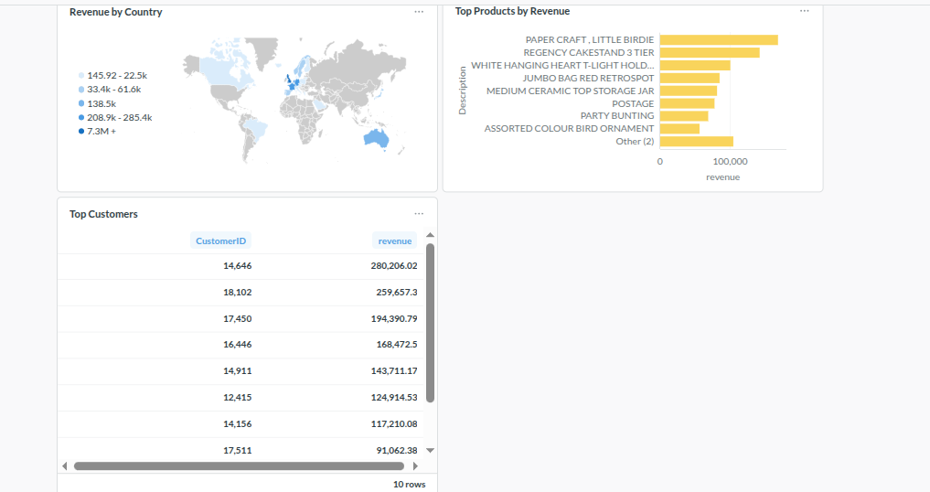

1. Revenue by Country
SELECT
Country,
SUM(Quantity * UnitPrice) AS revenue
FROM online_retail1
WHERE InvoiceNo NOT LIKE 'C%'
AND Quantity > 0
AND UnitPrice > 0
[[AND {{date_filter}}]]
[[AND Country = {{country}}]]
GROUP BY Country
ORDER BY revenue DESC;
Explanation: Identifies countries generating the most revenue, supporting geo-targeted strategies.

2. Top Products by Revenue
SELECT
Description,
SUM(Quantity * UnitPrice) AS revenue
FROM online_retail1
WHERE InvoiceNo NOT LIKE 'C%'
AND Quantity > 0
AND UnitPrice > 0
[[AND {{date_filter}}]]
[[AND Country = {{country}}]]
GROUP BY Description
ORDER BY revenue DESC
LIMIT 10;
Explanation: Shows top 10 revenue-generating products, useful for inventory and promotions planning.

3. Top Customers
SELECT
CustomerID,
SUM(Quantity * UnitPrice) AS revenue
FROM online_retail1
WHERE InvoiceNo NOT LIKE 'C%'
AND CustomerID IS NOT NULL
[[AND {{date_filter}}]]
[[AND Country = {{country}}]]
GROUP BY CustomerID
ORDER BY revenue DESC
LIMIT 10;
Explanation: Highlights highest-spending customers to support loyalty programs or targeted marketing.

